

Dr. Stephanie, Garza inc.

2016-01-27

Dr. Garza

568 Nicole Hills, New Jamestown, MD 42604

Phone: 9326192896

Fax: 3036407357

**Re:** Michele, Michael

**PHN:** 4157632149

**Birthdate:** 19-Jul-1953

**Address:** 362 Green Plains Suite 369, Wilsonview, WV 26376

**Patient number:** 663024548

To Whom It May Concern:

This is a medical letter to state the above patient is pregnant with expected delivery date of 26-Sep-2025. Hoping this information is satisfactory for your requirements.

Thank you.

Sincerely,

Dr. Stephanie, Garza

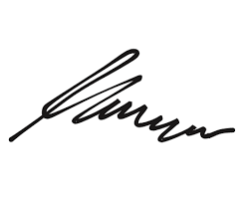

FRCS© NCMP

Clinical Assistant Professor, UBC

Department of Obstetrics and Gynecology SMH